http://steppe.cr.usgs.gov/obj.html
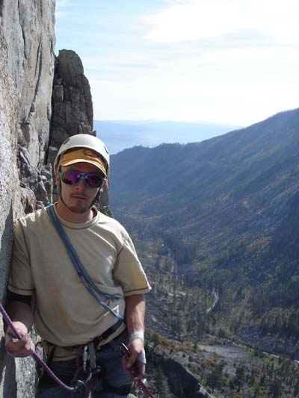
Todd Preston
USGS Brine Contamination to Prairie Potholes from Energy Development in the Williston Basin
This site represents the collaborative effort between scientists from Northern Rocky Mountain Science Center, Northern Prairie Wildlife Research Center, and Montana Water Science Center which initiated work to gather spatial datasets to identify areas most at risk to contamination, assess the spatial extent of past and current oil well development, and assess the potential impacts on aquatic resources in the Williston Basin.

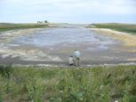

The management questions of scientific interest important to our model development include:
- Can we predict whether a wetland (natural, restored, and un-restored) functions as a groundwater recharge, discharge, or flow through site based on abiotic parameters (e.g., soils, water quality, geomorphology, watershed size, topographic position, surrounding land practices, etc.) and biotic parameters (e.g., wetland plants)? Groundwater/surface water interchange is particularly important because it influences soil genesis in the long term, and marsh plant and bird community development in the short term.
- Is there a difference in sediment and recently buried A horizons in seasonal wetlands between areas in native prairie, CRP, and those in areas having been tilled (dry land wheat) for at least 25 years? Can we estimate sedimentation trajectories?
- Is deposition a function of landscape position, land use, climate, or a combination of these?
- Does removal of sediment from seasonal wetlands to restore the basin’s original morphology result in restoration of wetland hydrology and plant communities?
Prairie Pothole Repeat Photography Project
This page features repeat photography of twelve prairie wetland sites in Sheridan County, Montana. The purpose of this project is to show the seasonal variation and progression of prairie pothole vegetation under three different land use practices: Cultivated Cropland (CL), Conservation Reserve Program (CRP), and Native Prairie (NP).

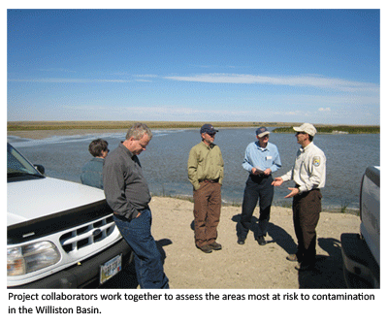
Project Objectives:
The USGS has placed a focused effort on providing a comprehensive understanding of the Nation’s energy and mineral resources and the environmental effects of their use. In response to this, a collaborative effort between scientists from Northern Rocky Mountain Science Center, Northern Prairie Wildlife Research Center, and Wyoming-Montana Water Science Center initiated work to gather spatial datasets to identify areas most at risk to contamination, assess the spatial extent of past and current oil well development, and assess the potential impacts on aquatic resources in the Williston Basin.
Currently, the team has located thousands of permitted oils wells in northeastern Montana and northwestern North Dakota. Wetlands and oil wells are often in proximity to each other throughout the area where the Williston Basin overlaps the PPR, and preliminary analysis in a representative drainage area in Montana indicated that there were 80 wetlands with oils wells within 50 meters of their edge. Additionally, the team has worked with county, state, and federal agencies to identify agency needs related to specific research objectives which include.
- Evaluate the spatial extent and potential risk to natural resources of past and ongoing energy development in the Williston Basin using Geographic Information System (GIS) analyses
- Reassess brine contamination movement in pilot areas
- Conduct a user needs analysis and design a prototype decision support system
- Establish an Interagency Energy Contamination Science Team

